APPLICATION FORM FOR THE PARTICIPANTS OF THE CONFERENCE
TaLC10

AT THE SOFITEL WARSAW VICTORIA HOTEL

SPECIAL OFFER

Single Superior Room 325 PLN / per night, breakfast included
Double/Twin Superior Room 380 PLN/ per night, breakfast included

Above rates are in PLN for one room and one night. Rates are inclusive of breakfast in Hetmańska Restaurant and VAT tax (currently 8% subject to change*). Room rates include free of charge high-speed internet access and unlimited access to the recreation centre (pool, fitness, hammam).
Check in time: from 2.00 p.m., check out time 12.00 a.m.
Family name_______________________________________________________________________
First name_________________________________________________________________________
Address__________________________________________________________________________
Phone number_____________________________________________________________________
Fax number _______________________________________________________________________
E- mail___________________________________________________________________________
Dates of reservation: from ____ /____ /______ to ___ / ____ /______
Type of room:

Single Twin
smoking room non-smoking room

Form of payment:

credit card
Name, number and expiry date of credit card: ___________________________________________________
Please note that Hotel will accept the reservation only with a credit card number (or prepayment) as a guarantee.

Rooms can be cancelled without any charge till 29.06.2012. For any cancellation after this date guest will be charged for the first night.
Please kindly send back this application form to the Reservation Department of Sofitel Warsaw Victoria Hotel (fax number: +48 22 657 81 69 or e-mail: H3378-RE@sofitel.com ).

We thank you very much for choosing Sofitel Warsaw Victoria and we wish you a magnifique stay in our hotel!

* In the event of changes to VAT values resulting from new taxing regulations an additional VAT charge, will be added to the net prices, according to the official VAT value of the day of the stay.

Confirmation number: Hotel’s signature:

Superior Rooms
The spacious, air-conditioned rooms with individual monitoring have been designed especially for business and individual travelers. They all feature the luxury “MyBed” - Sofitel exclusivity for a perfect sleep, safe, mini-bar, pay-TV, coffee/tea facilities, mineral water, and the latest technology, including complimentary high-speed internet access. The bathroom features French L’Occitane Cosmetics.
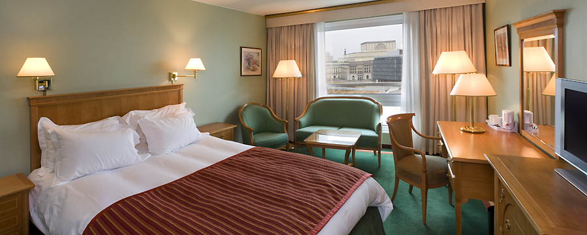

Breakfast
French Executive Chef – Olivier Croso invites you to a wealthy breakfast buffet, with Polish specialties as well as French patisserie, a large selection of warm and cold dishes, fresh juices. Enjoy a real breakfast feast and start the day with a smile.

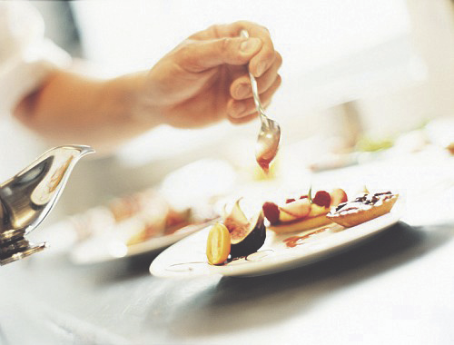

Leisure
The Recreation Centre is an extraordinary place in the hotel. The beautifully designed swimming pool, Fitness and hammam are an encouragement to relax and naturally replenish your energy. Guests of the Hotel have unlimited access to it.
