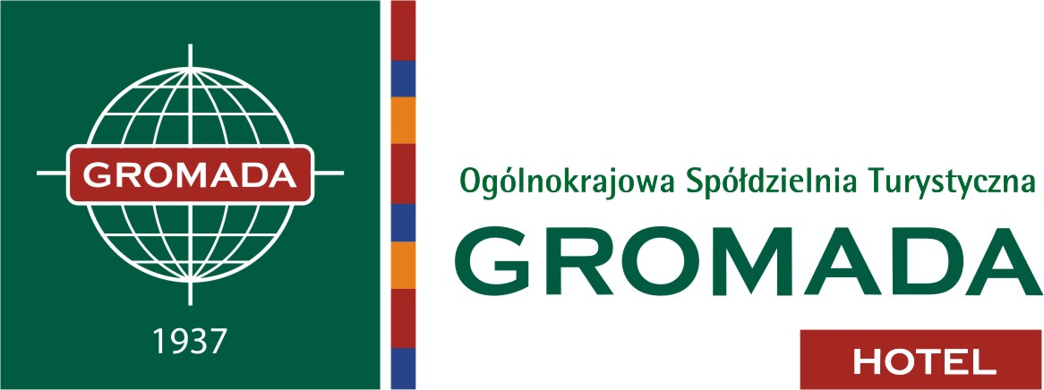
SPECIAL OFFER FOR THE PARTICIPATIONS OF
THE CONFERENCE TALC10

11-14.07.2012
Warsaw
( Reservation number TA306)
REGISTRATION FORM
Please complete in block capitals and return to ( till 31.05.2012):
Hotel Gromada “Dom Chłopa”, Powstancow Warszawy 2 sq., 00-030 Warsaw
Fax: +48 22 582-95-27, Tel.: +48 22 582-94-00
e-mail: warszawahotel.centrum@gromada.pl

Family name: First name: ______________________________________ ____________________________

method of payment:
_______________________________________________________________________

name, number and expiry date of credit card:
_______________________________________________________________________

Address:
___________________________________________________________________

City, Country, postcode:
___________________________________________________________________

Telephone: Fax:
_____________________________ ___________________________
e-mail:
___________________________________________________________________

Accommodation is planned at: three stars “Gromada Dom Chłopa” Hotel:
Single room economy 260PLN / per night 
Twin room economy 290PLN / per night 

Prices above include 8% VAT and breakfast.

Date of reservation: from: ______ to: ______

Contact for hotel’s reservation department: www.domchlopa.pl

Pl. Powstańców Warszawy 2
00-030 Warszawa
tel. /022/ 58 29 900
58 29 400
58 29 300
fax /022/ 58 29 527
warszawahotel.centrum@gromada.pl
www.gromada.pl

konto bankowe:
BRE BANK
25114010100000514114001038
NIP: 525-000-79-68

